  - Class Project
  - Nutritional Analytics from Code-switched Gastronomy Influencer Reels Using Prompt Engineering and Large Language Models

Project Artefact Declaration Document
  - Sem 2 2025/2026 | BITP 3123 Distributed Application Development

Group No:

List of Group Members
Matric No | Name

Instruction for Github submission
- Create a project in github using naming format masakgramprompt_groupNo.
- Replace the groupNo in the naming format with an actual group number.
- Create a directory named project.
- Push the whole project (and its structure) into the project directory.
- Then create another directory named transcription.
- Push all transcripts used in the project into the transcription directory.
Instruction for Project Artefact Submission
- Create a directory named project_artefact_groupNo.
- Replace the groupNo in the naming format with an actual group number.
- The directory should contain sub directories as described in Table 1.

Table 1: Sub directories description
Name | Description
database | Should contain a .sql file that export the database structure and its data used for the project.
metric_evaluation | A directory that should contain sample of data exported from the the project.

- Complete all sections in this document.
- This page should be removed before submission.
- Convert this document to PDF for submission.
- Put the PDF into the folder created in step no. 1 of this section.
- Compress the folder.
- Upload the submission in ulearn.

Platform Implementation
This section described the platform used to implement the project – either Java TCP/IP or Java Spring. State the link to the project in github.

List of files for the client-side solution
The section should describe and list the files used for the client-side solution. The list should include full directory path to the file. Segregate the files according to the package structure. All declared file must be consistent with the ones pushed in github.

List of files for the server-side solution
The section should describe and list the files used for the client-side solution. The list should include full directory path to the file. Segregate the files according to the package structure. All declared file must be consistent with the ones pushed in github.

Client-Side Solution
This section documents all screen related to the client-side in separate sub section. The subsection represents the screen name. Each screen documentation consists of the following: -
- Brief description of the screen that refers to the screen shot of the screen.
- Screen shot with caption label that represent the screen name.
- The class/files that implements the screen.
- Label of each GUI component in the screen shot.
- Each labelled component is describe using Table 2.
Table 2: GUI component description for ScreenX
Label | Object Name | Corresponding Class/Object | Method Implementation

- An example of screen description is shown in section 2.1.

Login Screen
The Login Screen serves as the entry point of the application, providing users with a secure interface to authenticate their identity before accessing the system. As shown in Figure 1, the screen presents a clean and structured layout consisting of a logo (A), a welcome message (B), input fields for email and password (C, D), a primary login button (E), a forgot password link (F), social login options via Google and Facebook (G, H), and a sign-up redirect link (I).
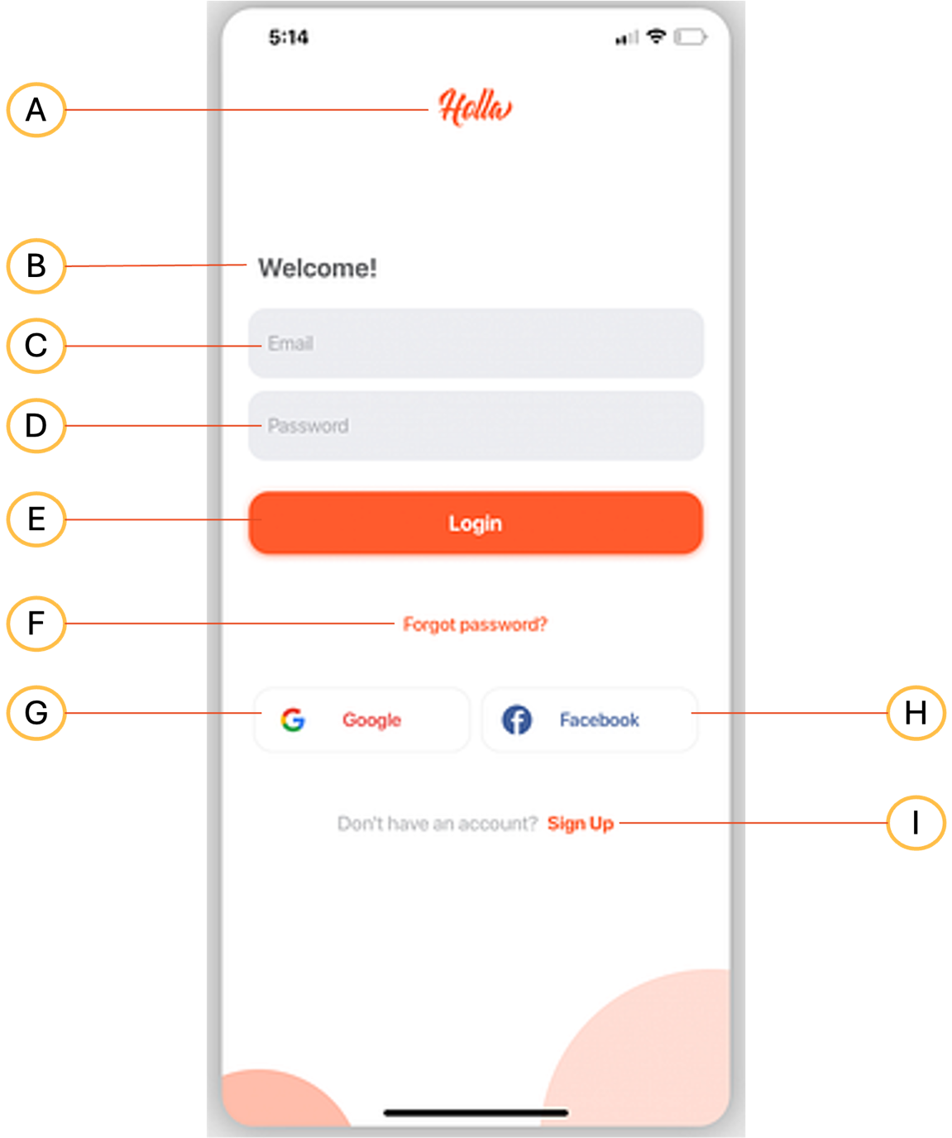
Figure 1: Login screen
Table 3 summarises the object name, corresponding class, and method implementation for each labelled component on this screen. The screen is implemented using login.jsp (fill-directory-path/login.jsp), which defines the visual layout and HTML structure of the interface. User interaction on this screen is handled by an accompanying JavaScript file, login.js, which manages client-side input validation, error feedback, and event handling for all interactive components including button clicks and link navigation.
Table 3: UI Components of the Login Screen (login.jsp)
Label | Object Name & Description | Corresponding Class/Object | Method Implementation
A | imgLogo — displays the application logo image at the top of the login screen | ImageView | onCreate()
B | tvWelcome — displays a static welcome or application title text | TextView | onCreate()
C | etEmail — accepts user input for the email address field | EditText | onCreate()
D | etPassword — accepts user input for the password field, with masked characters | EditText | onCreate()
E | btnLogin — submits the entered credentials to authenticate the user | Button | btnLogin_onClick()
F | tvForgotPassword — navigates the user to the password recovery page when clicked | TextView | tvForgotPassword_onClick()
G | btnGoogle — initiates login using the user's Google account via OAuth | Button | btnGoogle_onClick()
H | btnFacebook — initiates login using the user's Facebook account via OAuth | Button | btnFacebook_onClick()
I | tvSignUp — redirects the user to the registration page to create a new account | TextView | tvSignUp_onClick()

Server-Side Solution
This section documents all screens related to the server-side in separate sub sections. The sub section represents the screen name. Each screen documentation consists of the following: -
- Brief description of the screen that refers to the screen shot of the screen.
- Screen shot with caption label that represent the screen name.
- The class/files that implements the screen.
- Label of each GUI component in the screen shot.
- Each labelled component is describe using Table 2.

Project Artefact Declaration

Project Database File
All data used and generated from the project is recorded in a database named ________. The databased is exported into a file named _____.sql. The file is in the folder named database in the project submission artefact.

List of transcripts
This project uses the transcripts compiled in a directory named transcription at <insert_link_to_github>. The directory contains n transcripts.

Metric Evaluation Files
Sample of data for metric evaluation recorded in CSV files. The files are compiled in a directory named metric_evaluation. The directory contains the following files, consistent with the project specification.
- File1
- File2
- File n

End of Document

